**Executive Summary**

**Project Part 4**

**GROUP-10**

**Introduction:**

MediCrystals Co. is a big glass company in Germany that makes things like vials and syringes for medicine. They have factories in Europe, the US, and Asia and sell their products to many countries around the world. They make a lot of glass containers, over 8 billion every year! But lately, there has been a big jump in demand for their products, and they're worried they might not have enough glass to keep up. This could cause problems for other companies that make medicine, because they might not be able to get the glass bottles and vials they need.

**Challenges:**

The Vice President of Operations at MediCrystals has enlisted our expertise to address several critical areas, including:

* Assessing the impact on working capital through the estimation of inventory position changes.
* Analyzing marketing team-collected data on expected demand patterns.
* Providing insights into demand trends and identifying any potentially obsolete inventory that Glaswork may possess.

**Safety Stock Analysis:**

The Reorder Point (ROP) formula was calculated as:

**ROP = (LeadTimeDemand×SafetyFactor)+SafetyStock**

where Lead Time Demand is the average demand during lead time.

**Also,**

**Safety Stock = (Z-score * Demand Variability * Lead Time) / √Lead Time**

Where:

* Safety Factor corresponds to the Z-score for the desired service level (for example, for a 98% service level, you'd use the Z-score corresponding to 2% tail).
* Lead Time Demand is the average demand during lead time.
* Demand Variability is the coefficient of variance for demand.
* Lead Time is the lead time in days.

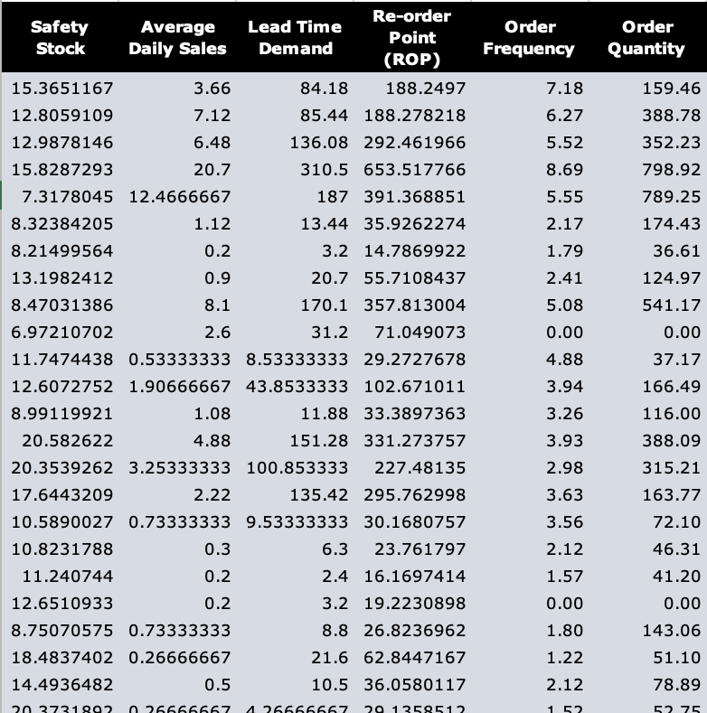

**Methodology:**

To forecast the expected trend in average price per unit (APU) for Glaswork's products, we will analyze "Data Exhibit-2" for the upcoming 12 months. By aggregating unit sales over the past year, we can project APU units for the next 12 months. This approach will provide detailed insights into the demand trend, aiding our communication with the marketing team.

**Dynamic Inventory Management Dashboard:**

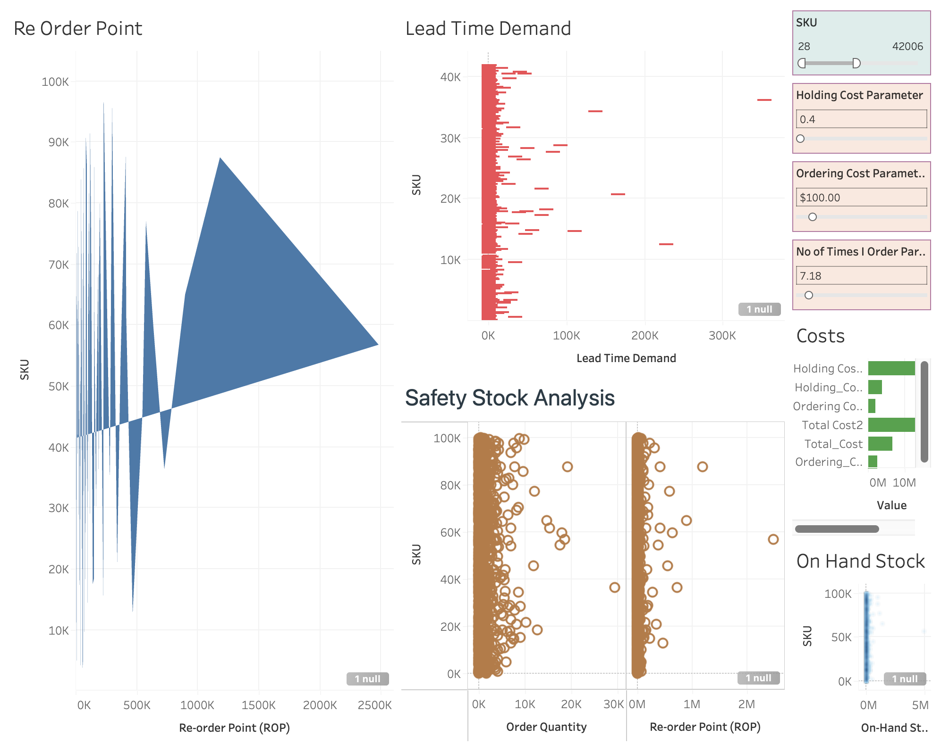

**Moving on to the next task:**

We'll create a new column called "On-Hand Inventory," calculated by dividing the dollar value of on-hand stock by the standard unit price. This calculation yields the available stock on hand, considering the expected APU units for obsolete inventory in the coming year.

This step is crucial as it highlights items that may be nearing obsolescence, such as SKU 52,607, which shows a significant amount of on-hand inventory. Recognizing excess and potentially outdated stock facilitates informed decisions regarding procurement, based on SKU and on-hand inventory data.

Ultimately, disclosing the current inventory on hand is essential for identifying potential obsolete products within the system. This method simplifies the identification of Stock Keeping Unit (SKU) numbers at risk of obsolescence.

Suppliers of Medicrystal can make informed decisions when equipped with knowledge of Glaswork's current supply and the expected demand trend.